For the student, teacher, and staff attendance app in React, you can organize the project into several modules, sections, and tables to cover all required functionalities. Here's a detailed breakdown.

**1. Modules**

* **Authentication Module**
  + Handles login, registration, and profile management for students, teachers, and staff.
* **Dashboard Module**
  + Provides a centralized view for users based on their roles (student, teacher, staff).
* **Attendance Module**
  + Manages daily attendance records for students, teachers, and staff.
* **Leave Management Module**
  + Allows users to apply for leave, view leave history, and manage leave requests.
* **Reports Module**
  + Generates attendance and leave reports for analysis and record-keeping.
* **Admin Module**
  + Provides administrative controls for managing users, roles, and permissions.

**2. Sections**

* **Login/Registration**
  + User login (Students, Teachers, Staff)
  + Registration form for new users (optional if only admins create accounts)
  + Profile management
* **Dashboard**
  + Overview of attendance, leave requests, and notifications
  + Role-specific information display (e.g., student attendance summary, teacher attendance records)
* **Attendance Management**
  + Mark attendance (Students, Teachers, Staff)
  + View attendance history
  + Update or correct attendance records
* **Leave Management**
  + Apply for leave (Sick Leave, Holiday, Absent)
  + View leave status and history
  + Admin approval/rejection of leave requests
* **Reports**
  + Generate and download attendance reports
  + View monthly/weekly attendance statistics
  + Leave summary reports
* **Admin Panel**
  + Manage users (create, update, delete)
  + Define roles and permissions
  + Configure leave types and policies
  + Monitor system usage and performance

**3. Database Tables**

* **Users**
  + id (Primary Key)
  + name
  + email
  + password
  + role (Student, Teacher, Staff, Admin)
  + profile_picture
  + created_at
  + updated_at
* **Attendance**
  + id (Primary Key)
  + user_id (Foreign Key to Users table)
  + date
  + status (Present, Absent)
  + remarks (Optional notes)
  + created_at
  + updated_at
* **Leave Requests**
  + id (Primary Key)
  + user_id (Foreign Key to Users table)
  + leave_type (Sick Leave, Holiday, Absent)
  + start_date
  + end_date
  + status (Pending, Approved, Rejected)
  + reason
  + created_at
  + updated_at
* **Roles**
  + id (Primary Key)
  + role_name (Student, Teacher, Staff, Admin)
  + created_at
  + updated_at
* **Permissions**
  + id (Primary Key)
  + role_id (Foreign Key to Roles table)
  + permission_name
  + created_at
  + updated_at
* **Leave Types**
  + id (Primary Key)
  + name (Sick Leave, Holiday, Absent)
  + description
  + created_at
  + updated_at

**4. Additional Considerations**

* **Notifications**
  + You might want to include a notifications table to handle alerts for leave approvals, attendance updates, etc.
* **Audit Logs**
  + To track changes made by admins or users, consider an audit log table

**1. Users Table**

* **Relationships:**
  + Users have a one-to-many relationship with Attendance (one user can have multiple attendance records).
  + Users have a one-to-many relationship with Leave Requests (one user can submit multiple leave requests).
  + Users have a many-to-one relationship with Roles (each user has one role, but each role can belong to many users).

**2. Roles Table**

* **Relationships:**
  + Roles have a one-to-many relationship with Users (each role can be assigned to multiple users).
  + Roles have a one-to-many relationship with Permissions (each role can have multiple permissions).

**3. Attendance Table**

* **Relationships:**
  + Attendance has a many-to-one relationship with Users (each attendance record is linked to one user).

**4. Leave Requests Table**

* **Relationships:**
  + Leave Requests has a many-to-one relationship with Users (each leave request is submitted by one user).
  + Leave Requests has a many-to-one relationship with Leave Types (each leave request corresponds to a specific leave type).

**5. Permissions Table**

* **Relationships:**
  + Permissions have a many-to-one relationship with Roles (each permission is associated with one role).

**6. Leave Types Table**

* **Relationships:**
  + Leave Types have a one-to-many relationship with Leave Requests (each leave type can be associated with multiple leave requests).

**Visual Representation**

Here's how these relationships would look in an entity-relationship diagram (ERD):

1. **Users Table**
   * **One-to-Many with Attendance Table**: Each user (user_id) can have multiple attendance records (user_id in the Attendance table).
   * **One-to-Many with Leave Requests Table**: Each user (user_id) can submit multiple leave requests (user_id in the Leave Requests table).
   * **Many-to-One with Roles Table**: Each user (role_id) is associated with one role (id in the Roles table).
2. **Roles Table**
   * **One-to-Many with Users Table**: Each role (id) can be assigned to multiple users (role_id in the Users table).
   * **One-to-Many with Permissions Table**: Each role (role_id) can have multiple permissions (role_id in the Permissions table).
3. **Attendance Table**
   * **Many-to-One with Users Table**: Each attendance record (user_id) is associated with one user (id in the Users table).
4. **Leave Requests Table**
   * **Many-to-One with Users Table**: Each leave request (user_id) is associated with one user (id in the Users table).
   * **Many-to-One with Leave Types Table**: Each leave request (leave_type_id) corresponds to one leave type (id in the Leave Types table).
5. **Permissions Table**
   * **Many-to-One with Roles Table**: Each permission (role_id) is associated with one role (id in the Roles table).
6. **Leave Types Table**
   * **One-to-Many with Leave Requests Table**: Each leave type (id) can be associated with multiple leave requests (leave_type_id in the Leave Requests table).

**Example ERD (Entity-Relationship Diagram) Structure**

* **Users** → user_id (PK) → **Attendance**
* **Users** → user_id (PK) → **Leave Requests**
* **Roles** → role_id (PK) → **Users**
* **Roles** → role_id (PK) → **Permissions**
* **Leave Types** → leave_type_id (PK) → **Leave Requests**

This diagram would show the primary keys (PK) and foreign keys (FK) linking the tables, reflecting the relationships described above. The "one-to-many" relationships indicate how one record in a table (e.g., a User) can be linked to many records in another table (e.g., multiple Attendance records)

*Work Flow:

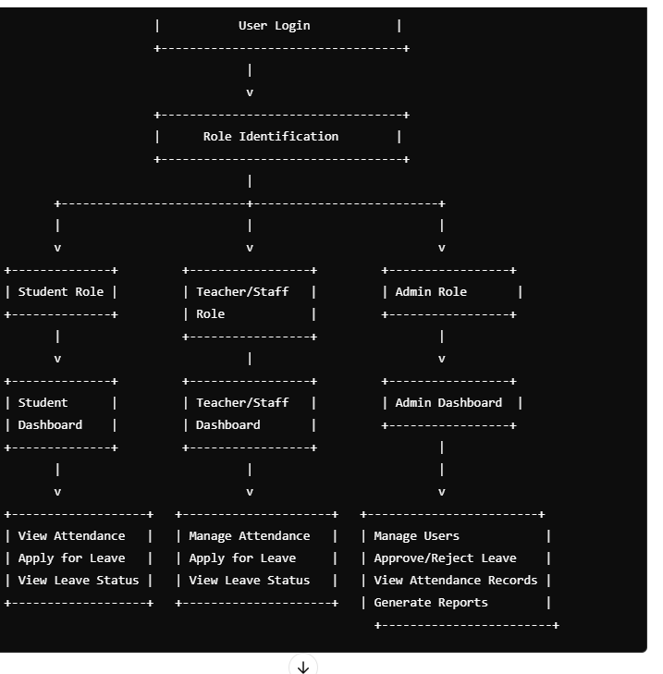

### Workflow Diagram Overview

1. **User Authentication and Role Identification**
   * **User Login/Registration**
   * **Role Identification** (Student, Teacher, Staff, Admin)
   * **Dashboard Access** based on Role
2. **Dashboard Interaction**
   * **Student Dashboard**
     + View Attendance Summary
     + Apply for Leave
     + View Leave Status
   * **Teacher/Staff Dashboard**
     + View Personal Attendance
     + Manage Student Attendance (Teacher only)
     + Apply for Leave
     + View Leave Status
   * **Admin Dashboard**
     + Manage Users (Create/Update/Delete)
     + View All Attendance Records
     + Approve/Reject Leave Requests
     + Generate Reports
3. **Attendance Management**
   * **Mark Attendance**
     + Select Date
     + Mark Present/Absent
     + Submit Attendance
   * **View Attendance**
     + Daily/Weekly/Monthly View
     + Attendance History
     + Export/Download Reports
4. **Leave Management**
   * **Apply for Leave**
     + Select Leave Type (Sick Leave, Holiday, Absent)
     + Select Dates (Start/End)
     + Submit Reason
     + Wait for Approval
   * **Admin Actions**
     + Review Leave Requests
     + Approve/Reject Requests
     + Notify User of Decision
5. **Report Generation (Admin Only)**
   * **Select Parameters**
     + Choose Date Range
     + Select User Group (Students/Teachers/Staff)
     + Generate Report